

|  |
| --- |
|  |
| sql injection |
| bug report |
| **Chetan Pujari | chetanpujari125@gmail.com** |



|  |  |
| --- | --- |
|  | Decorative |
| sql injection |
| In sql injection bug, attacker try to inject the sql queries which generates the error in the site and login as admin without username and password. |



**PRACTICAL** **EXPLANATION**



1. **THIS IS OUR CLG SITE :-**

**http://27.54.181.205/bmef/index.php**

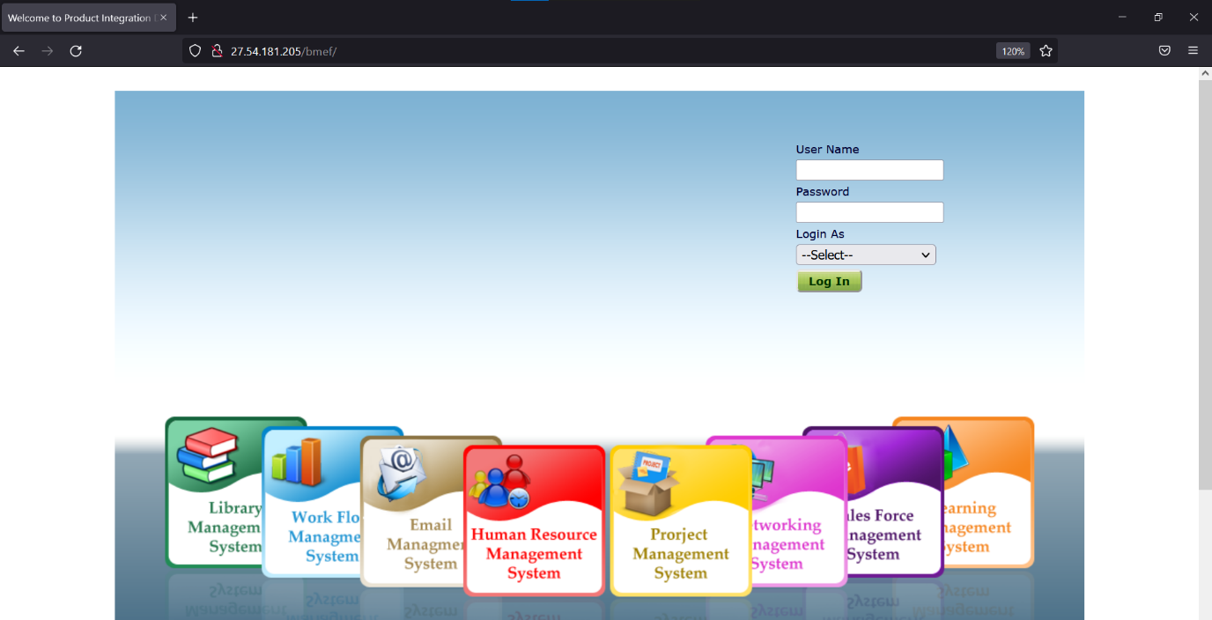

**2.**

Here ,

There is login page which required the username and password.

Here we input the sql query in the username and we select the login as ADMIN.

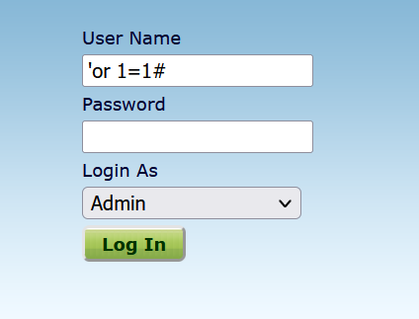

Here the list of sql query which bypass the login page in site:-

'or 1=1#

admin' #

'or 1=1 or ''='

'=' 'or' and '=' 'or'

**3.WE ARE INTO THE ADMIN PAGE NOW without username and password.**

